**Aarish Salam Memon – A20499744**

**Staging Process** – In this process we have created a rest client to get data from online and download it, after that it goes through JSON input and stores it in a staging table

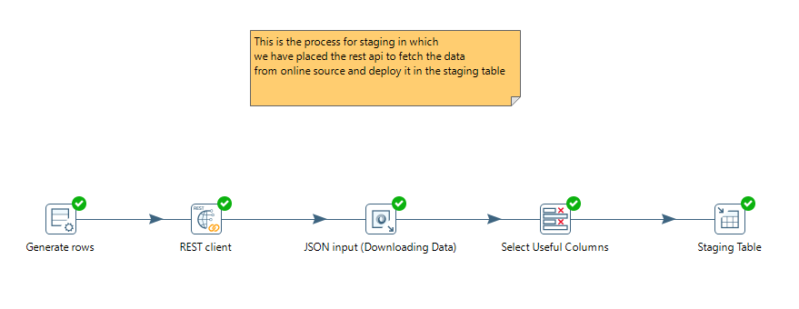

**Destructive Loading (Staging to Final)** – Then we send the data from staging table to the final target table.

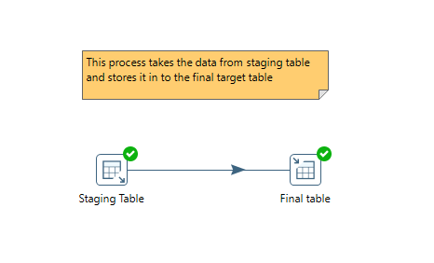

**CDC Process –** This is the process for change data capture, in this process we connect the two tables staging and final target table we merge them capture the difference.

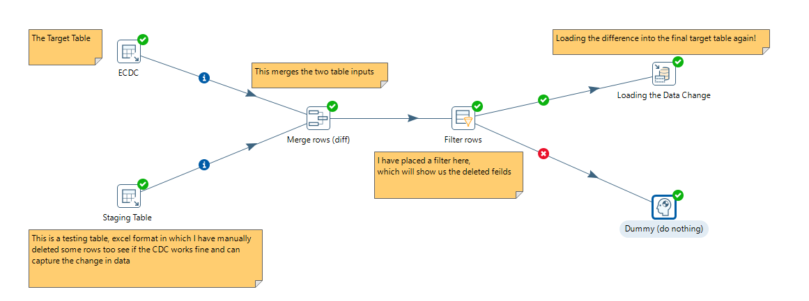

**Testing Table Creation –** Just for testing purposes we have downloaded the same data in XLS format, deleted a few rows to check if the CDC Works.

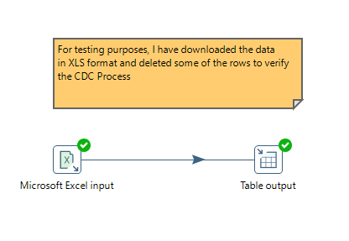

**CDC Testing Process –** In this process, we have used CDC to check where the deleted rows are capture or not and then finally deploying the deleted data in to the final target table.



I also have created a job to execute all the transformations step by step, with triggers to initiate and to halt.

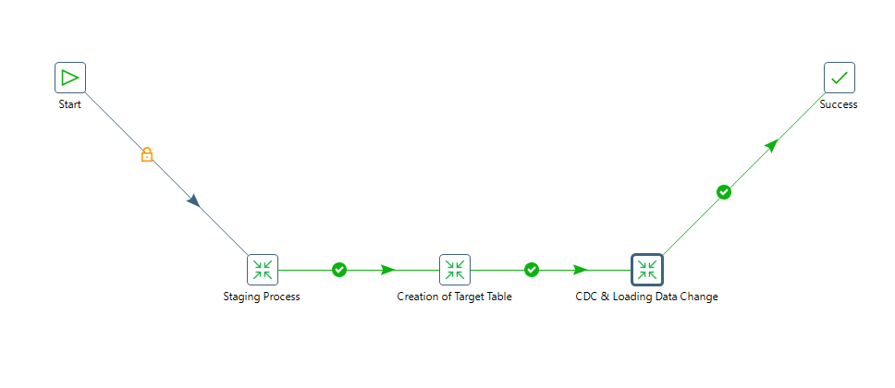

**Testing Documentation**

Testing file format – XLS

Testing Data – Same as picked for Covid Testing

Operations Done – Deleted, Changed

Process – CDC



I manually deleted and changed some of the rows in the Excel file format to compare whether the CDC is working fine or not, created a staging table for XLS and merge it with the final target table and the flag field identified there are a few rows that are changed or deleted, after we filtered those rows out in the filter cell and then transferred the captured change into the target table again and the rest of it goes to dummy.